|  |  |
| --- | --- |
| **California Career Resource Network Career Exploration Resources** | calcrn_logo |

The California Career Resource Network (CalCRN) provides career development resources to promote improved career and education decision-making. Housed at the California Department of Education (CDE), CalCRN’s free and low-cost career exploration resources are tailored to California’s middle and high school students, but available to all Californians.

CalCRN's home page ([www.californiacareers.info](http://www.californiacareers.info)) has links to all CalCRN resources, background documents, and the calendar of CalCRN meetings.

The **California Career Center (CalCC)** ([www.calcareercenter.org](http://www.calcareercenter.org)) Web portal is a comprehensive source for career and college resources and tools to help students map their futures. Though CCC’s focus is on students, it contains resources for counselors, teachers, parents, and guardians. Free user account feature.

The **California CareerZone** ([www.cacareerzone.org](http://www.cacareerzone.org/)) is a Web-based career exploration system providing four easy to use career assessment tools that connect users with information on California occupational options and colleges. Now includes the “Make Money Choices” budgeting feature. Free user account feature and free downloadable workbook (8 pages). Send feedback, comments, and/or questions to [feedback@cacareerzone.org](mailto:feedback@cacareerzone.org).

**Career Surfer Mobile Application**

This mobile application will enable students to explore careers from their mobile devices, download from iTunes or Google Play.

The **California Career Planning Guide** ([www.californiacareers.info/ccpg.html](http://www.californiacareers.info/ccpg.html)) is a hard copy resource (100 pages) that guides students in developing a personal career action plan. From CalCRN’s Web site, users can download free English and Spanish graphic versions and English and Spanish text versions.

**The Real Game California (TRGC)** ([www.realgamecalifornia.org](http://www.realgamecalifornia.org)) is a classroom-based career exploration curriculum. TRGC helps students acquire the skills, knowledge, and attitudes necessary to be career self-managers for life. Available via annual subscription.

The **Support Personnel Accountability Report Card (SPARC)** ([www.sparconline.net](http://www.sparconline.net)) provides schools a unique, publishable document highlighting a school’s outstanding student support staff, programs, and impact on student career and college readiness.

To join **the CalCRN e-mail list** write to John Merris-Coots at the email address below or go to: <http://www.calcareercenter.org/Home/Content?contentID=308>

*John Merris-Coots* [*jmerris@cde.ca.gov*](mailto:jmerris@cde.ca.gov) *(916) 324-8151*

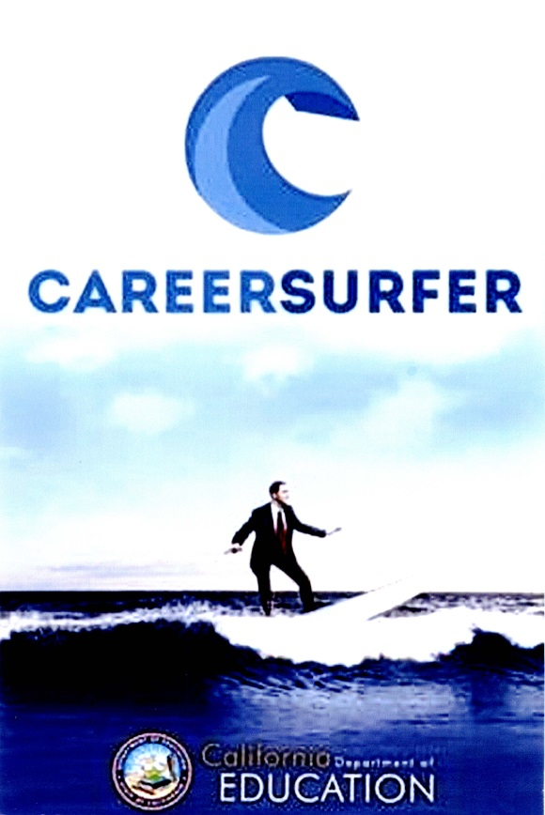

**QUICK START GUIDE**

Download Career Surfer from either iTunes or Google Play

Search for an occupation using all the Career Surfer Options:

* O\*Net Job Family
* Desired Salary and Education Level
* Key Word (choose any word you want related to finding an occupation)
* Shake Phone for Random

Fill in the boxes below for an occupation you discover by each method. Are they the same or did you find four different occupations. Identify occupations that will enable you to pursue your passion, use skills you now have or want to develop, provide the salary to support your desired lifestyle, or make a difference in your community.

Go to the California CareerZone ([www.cacareerzone.org](http://www.cacareerzone.org)) for greater detail on any occupation(s) that interest you, and explore the education and training required to get you to your occupational goal.

|  |  |  |  |  |
| --- | --- | --- | --- | --- |
| Occupation | Job Family | Key Tasks | Salary | Required Education/Training |
| **Job Family Search** | | | | |
|  |  |  |  |  |
| **Desired Salary and Education** | | | | |
|  |  |  |  |  |
| **Key Word Search** | | | | |
|  |  |  |  |  |
| **Random** | | | | |
|  |  |  |  |  |

|  |  |
| --- | --- |
| ***California CareerZone***  ***Quick Start***  [***www.cacareerzone.org***](http://www.cacareerzone.org) | cid:8457E2AD-7717-4A90-A607-38962744E6E5@internal.iradix |

Go to the California CareerZone home page at [www.cacareerzone.org](http://www.cacareerzone.org) and select “Register Now!” Set up an account with the following information:

* User Name
* Password
* Zip Code
* School Name
* Select “Student”
* Select “Graduation Year”

After the account is set up, go to <http://www.cacareerzone.org/quick> and take the *Quick Assessment*. Follow the directions on the page so you can discover occupations that match your interests. What is your three letter “Holland Code”? \_\_\_ \_\_\_ \_\_\_

As you explore occupations and colleges, rate and/or bookmark any that look interesting, to save in your account.

Fill in the boxes below for the five occupations that look interesting to you. Identify occupations that will enable you to pursue your passion, use skills you now have or want to develop, provide the salary to support your desired lifestyle, or make a difference in your community.

|  |  |  |  |  |
| --- | --- | --- | --- | --- |
| **Occupation** | **Salary** | **Required Knowledge/Skills** | **Required Education/Training** | **Education/Training Options** |
|  |  |  |  |  |
|  |  |  |  |  |
|  |  |  |  |  |
|  |  |  |  |  |
|  |  |  |  |  |

Choose an occupation that looks interesting and go to the occupations page in CareerZone, select “Create a Plan” from the left hand column, then select “Plan for Career Exploration.” Complete a draft of your plan.

**California CareerZone Quick Start - Educator Notes**

Take a few moments to establish an account of your own on the California CareerZone by selecting Register Now! at [www.cacareerzone.org](http://www.cacareerzone.org). Use the quick assessment to begin exploring the site and use the Explore, Decide, Grow dropdown menus to discover tools and features.

Students can establish a free account with no foreseeable expiration date once the account is established.

* It is helpful for CalCRN’s user tracking if they indicate “student” and supply the school name.
* An email address is only required as the means to help students if they forget their user name or password.
* It may be helpful to establish a common formula for user names and passwords by using first initial and last name for the user name, and schools initials with the current year for the password, for example jryan and AHS2013.

The California CareerZone account can save results from the Interest Profiler, Work Importance Profiler, and Skills Profiler. Results from the Quick Assessment can’t be saved, but students can still bookmark, rate, and email occupations and colleges of interest.

Tip: To help student with the “Talk to Someone” section of the plan, check out Professional Association listings at:

* California Career Café [www.cacareercafe.com/cool-connections/](http://www.cacareercafe.com/cool-connections/)
* U.S. Career One Stop [www.careeronestop.org/ProfAssoc](http://www.careeronestop.org/ProfAssoc)

**California CareerZone Educator Account Set Up**

As an educator you can monitor student activity by establishing an educator management account or by simply having students email content to you from the site. With the account management feature, you can also adapt and assign plans for your students to complete.

1. Set up a CareerZone Account by selecting “Sign In” on the CareerZone <http://www.cacareerzone.org/>

If you already have an account go to step 2

1. Log in to your account

Request an account by adding “requestmanagement” to the url

or copy and paste this <http://www.cacareerzone.org/requestmanagement>

Fill in the required information on the Request Management page

1. After the Educator Account is created go to the User Reporting and Management page by scrolling over “Manage”
   1. Scroll to the bottom of the page
   2. Select User Management Guide
   3. To view the entire guide add “all” to the url
   4. <http://www.cacareerzone.org/guide/usermanagement/all>
2. Follow the directions in the User Management Guide
3. If you have questions select “Let Us Know” at the bottom of the User Reporting and Management page

|  |  |
| --- | --- |
| **California Career Center**  **Quick Start**  [**www.calcareercenter.org**](http://www.calcareercenter.org) | [http://www.californiacareers.info/logos/ccc.jpg](http://www.calcareercenter.org/) |

Set up an account on the California Career Center (CalCC) account creation page at <http://www.calcareercenter.org/Portfolio/Profile>. Information required:

* Email address
* Password
* First Name
* School
* Zip Code
* Grade

Select appropriate boxes under “Why did you come to the California Career Center?”

After the account is established select the “My Stuff” tab, after the page loads, notice that CalCC has generated suggestions for content pages that might be of interest based on information you provided during the account set-up. (Note that the items selected when you set up your account can be changed at any time by selecting “Profile” under the “My Stuff” tab.) Choose a section that looks interesting and explore pages in that section, choose pages to be saved; these will be saved in your “My Stuff” account for easier call-back.

Go to the CalCC home page and select California Career Center User's Guide and review the content available on CalCC

Get started on your career exploration and planning journey by using the tabs on the left side of the page.

* **My Stuff** is where you save your High School Plan, Career Action Plan, and critical discoveries you make on your journey through the site.
* **Middle and High School** information helps you plan your school years so you have a path to the future you want to achieve.
* **Career Options** is where you’ll create your Career Action Plan. Identify your interests and abilities and see how they impact your goals and plans.
* **Getting a Job** is where you’ll find help no matter what kind of job you’re looking for, whether it’s a part-time job during school or your life-long dream job.
* **Education and Training** outlines your full range of post-high schools options.
* **Challenges** resources for your career journey are for you if you face various challenges from disabilities to homelessness.
* **Money Management** has the basics of financial literacy and ideas on paying for training and college.
* **Videos** show students’ talking about their job and college experiences.

**CalCC Resources for Educators**

**Career Action Plan (rubric available)**

* Career field/occupations that looks interesting to you
* Are there other career fields/occupations that look like a good match for you?
* What skills, training, education, certification and/or license will you need in order to be successful on the job?
* What colleges or training programs could you attend to prepare for your preferred occupations?
* What have you *done in the past* to prepare you for the workforce.
* What can you do *in the future* to prepare for the world of work.
* Name two or three people who you can count on to help you--describe your relationship to them in parenthesis. Example: Mrs. Smith (English Teacher)
* List two organizations that may be able to help you, include contact information- name, address, phone number, e-mail. Examples are Rotary Club, PFLAG, etc.
* Identify the steps you need to take between now and high school graduation to prepare for the transition from school to either additional training or work. Make this list as detailed as possible and put the items in chronological order.
* Colleges/training programs to consider for further research…

**Lesson Plan Creator**

* Outline
* ASCA National Standards for Students
* CalCC Content Pages
* Activity
  + Essay
  + Drop down
  + Multiple Choice
  + Etc
* Classes

**Classroom Ready Curriculum - 17 lessons posted in PDF and Word (to allow editing)**

Middle School Guidance Curriculum Lessons

Introduction to the California Career Center   
Let’s Party (Interest Inventory)   
What’s Important? (Values Inventory)   
Where Am I Going? (Crosswalking Interests and Values with Career Choices)   
S.M.A.R.T. Goal Setting   
My College/Career Action Plan (Putting It All Together)   
Course Planning (Six-Year Plan)   
Career Research Project   
PowerPoint Career Research Project

High School Guidance Curriculum Lessons

Introduction to the California Career Center   
Interest Profiler and Work Importance Profiler   
Identifying Abilities, Strengths and Skills, and Crosswalking to Careers   
My College/Career Plan (Putting It All Together)   
Course Planning (Four-Year Plan)   
Senior Portfolio   
Test-Taking Skills   
A-G Requirements